**Robot Design Documentation**

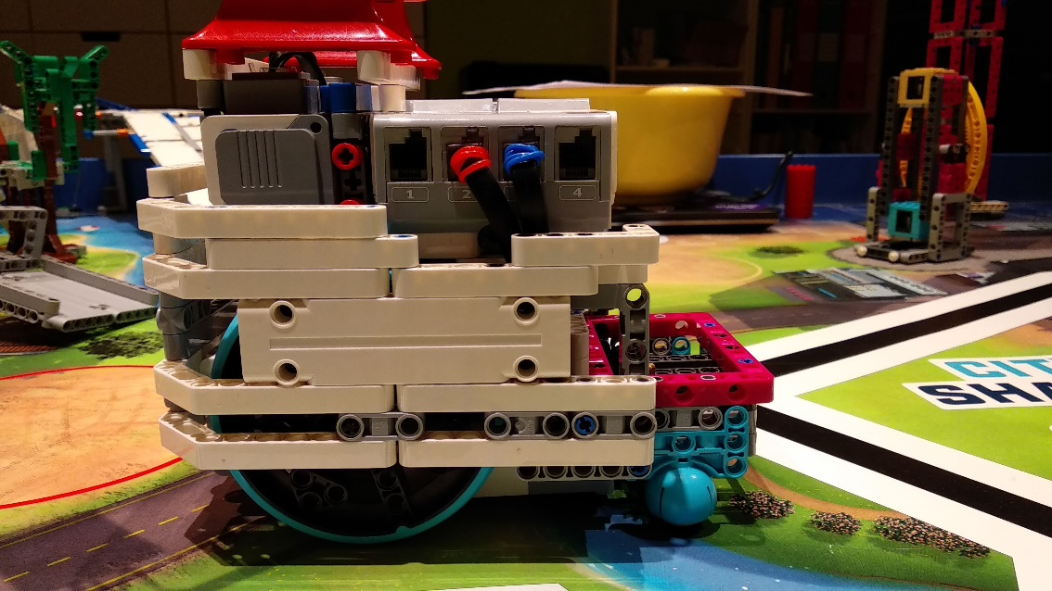Team TövisASAP 2019-20   
Documentation for our great and innovative **SNEAKY** robot  
**Modular, Stable, Precise, Gentle  
S.D.P.S.I.**

Hardware

**Systematic Design Process for Strategy and Innovation**

**Pre-Season  
Design System**

**We have applied**

**Systematic Design Process for Strategy and Innovation  
S.D.P.S.I.**

**In-Season  
Design System**

**Robot Strategy** **improvements|| regional 🡪 SF**

|  |  |  |
| --- | --- | --- |
| Round name | Regional Round Version | Semi Final Version – with improvements |
| Round „Treebat”  (Now we call this round „Crane” because we connected it to mission „Crane”) | It was full of movement that’s why it was too slow and inaccurate. | Now we are using a more complex attachment with pneumatics so we **don’t need to navigate that much** so it became simpler and we **connected** this round to round „Crane”. |
| Round „Bee”  (We do not have this round anymore, we connected it to round „South”) | It was also full of movement so it was 1 minute long, it was just 65 points and it was also inaccurate | We **connected** it to mission „South” so the **point/second rate of this mission is now better**. We take up a new task, mission Elevator and we made this whole round **more accurate** |
| Round „South” | It was too complicated and this was the cause of mistakes. This attachment had many weak points beacause of its complexity | Now it is **simpler** because we use just **passive solutions** and it is **more accurate** because we align many times to the wall or to lines. |
| Round „Bridge” | It was a good and reliable round but we had difficulties with the gear transmission because it was too weak and the movement of this arm was too inaccurate. And we had some problems with the solution that pushes down the flags, it was unreliable | We changed the thing on the attachment that pushes down the flags so it is **more reliable**. We also **changed the gear transmission** and now it is stronger and more accurate. |

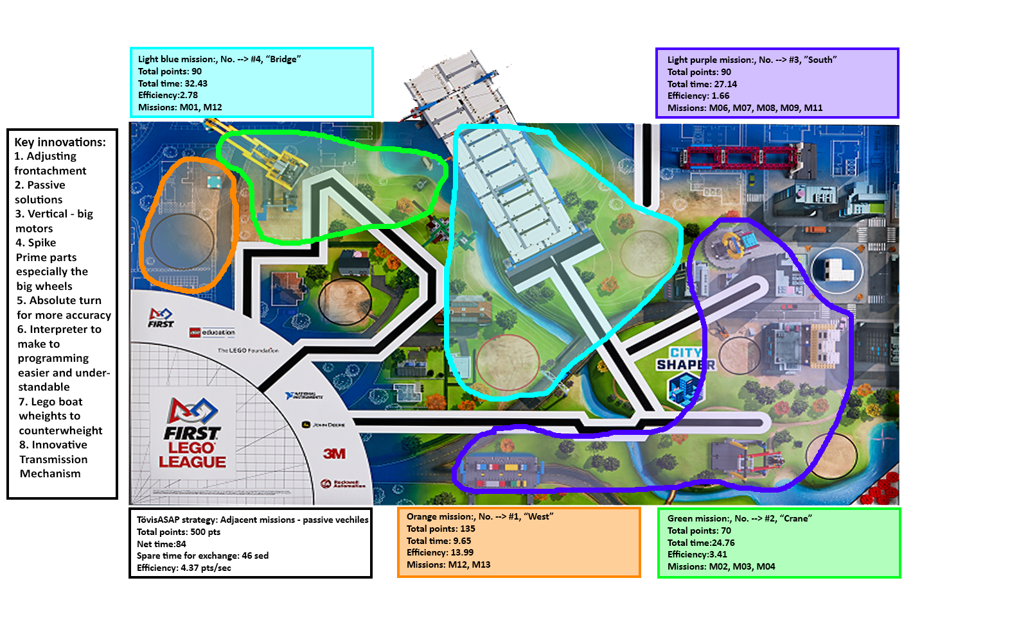**Mission Strategy – SF(improved)**

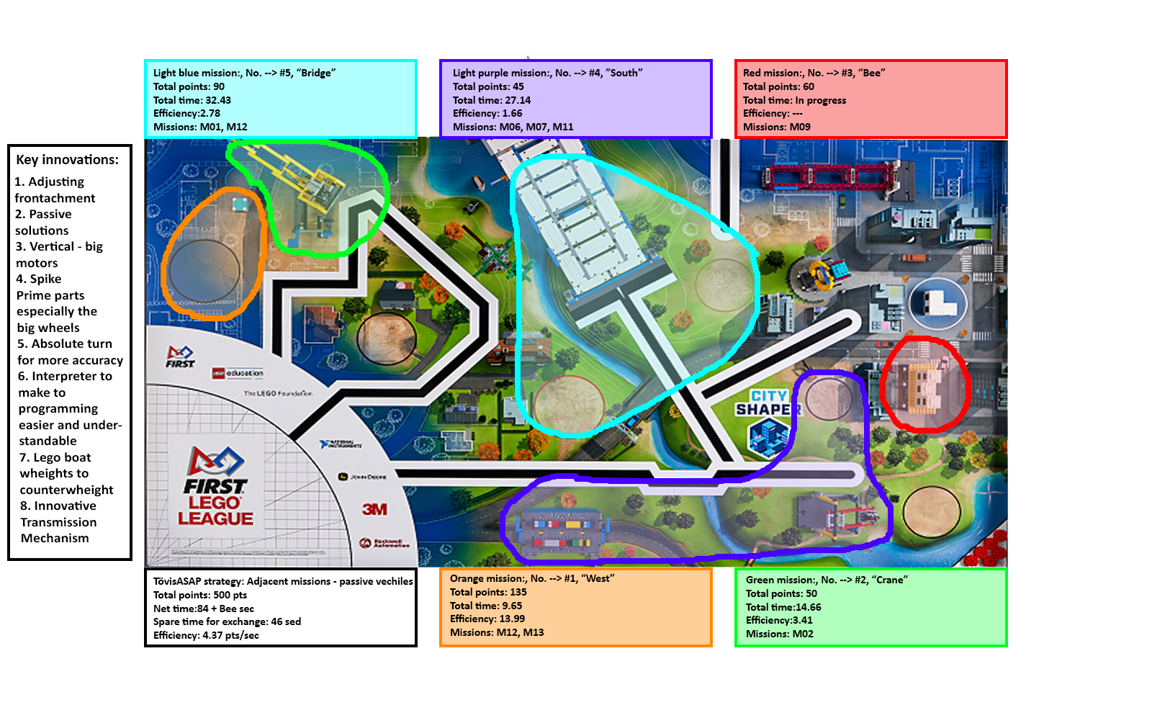**Mission Strategy – Regional(old)**

Our goal: very clear, purposefully to maximize points

**Mission Efficiency – SF**

|  |  |  |  |  |  |  |
| --- | --- | --- | --- | --- | --- | --- |
| **Round** | **Mission** | **Points** | **Total points** | **Time(sec)** | **Run safety(%)** | **Points/sec** |
| 0.round |  |  | 45 | ------ | ------ | ------ |
|  | Advantage(8 missions + M02 bonus) | 45 |  |  |  |  |
| 1.Round |  |  | 135 | 9.65 | 85 | 13.99 |
| West | Design & Build(SumHeight: 21) | 105 |  |  |  |  |
|  | Sustainability upgrades x3 | 30 |  |  |  |  |
| 2.Round |  |  | 50 | 14.66 | 95 | 3.41 |
| Crane | Crane | 50 |  |  |  |  |
| 3.Round |  |  | 60 | In progress |  |  |
| Bee | Safety factor | 60 |  |  |  |  |
| 4.Round |  |  | 45 | 27.14 | 80 | 1.66 |
| South | Traffic Jam | 10 |  |  |  |  |
|  | Swing | 20 |  |  |  |  |
|  | Innovative Architecture | 15 |  |  |  |  |
| 5.Round |  |  | 90 | 32.43 | 90 | 2.78 |
| Bridge | Design & Build(2 colors) | 40 |  |  |  |  |
|  | Elevated Places | 50 |  |  |  |  |
| Extra points |  |  | 75 | ------ | ------ | ------ |
|  | Design & Build(1 color) | 10 |  |  |  |  |
|  | Design & Build(SumHeight: 1) | 5 |  |  |  |  |
|  | Precision | 60 |  |  |  |  |
| Total |  |  | 500 | 83.88+Bee | 87.5 | 4.368 |

**Mission Strategy**

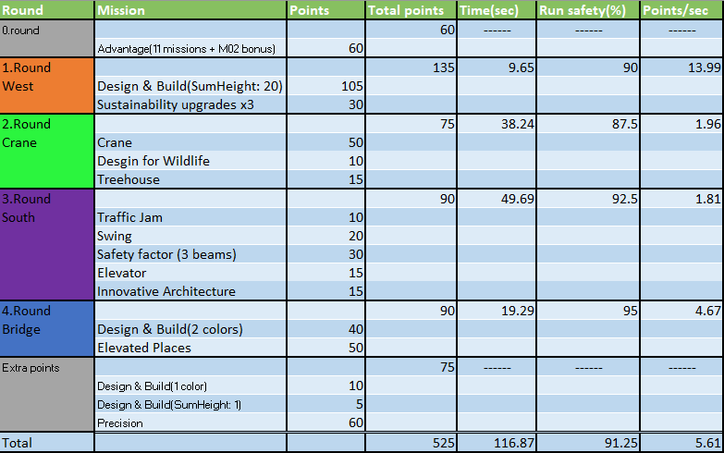We divide the mat, like this we could established the most effective rounds. We measured the **point/second** progress too, so we know in witch round to optimize.

**Mission Strategy**

**Mission Strategy**

**Mission Efficiency - regional**

|  |  |  |  |  |  |  |
| --- | --- | --- | --- | --- | --- | --- |
| **Round** | **Mission** | **Points** | **Total points** | **Time(sec)** | **Run safety(%)** | **Points/sec** |
| 0.round |  |  | 45 | ------ | ------ | ------ |
|  | Advantage(8 missions + M02 bonus) | 45 |  |  |  |  |
| 1.Round |  |  | 135 | 9.65 | 85 | 13.99 |
| West | Design & Build(SumHeight: 21) | 105 |  |  |  |  |
|  | Sustainability upgrades x3 | 30 |  |  |  |  |
| 2.Round |  |  | 50 | 14.66 | 95 | 3.41 |
| Crane | Crane | 50 |  |  |  |  |
| 3.Round |  |  | 60 | In progress |  |  |
| Bee | Safety factor | 60 |  |  |  |  |
| 4.Round |  |  | 45 | 27.14 | 80 | 1.66 |
| South | Traffic Jam | 10 |  |  |  |  |
|  | Swing | 20 |  |  |  |  |
|  | Innovative Architecture | 15 |  |  |  |  |
| 5.Round |  |  | 90 | 32.43 | 90 | 2.78 |
| Bridge | Design & Build(2 colors) | 40 |  |  |  |  |
|  | Elevated Places | 50 |  |  |  |  |
| Extra points |  |  | 75 | ------ | ------ | ------ |
|  | Design & Build(1 color) | 10 |  |  |  |  |
|  | Design & Build(SumHeight: 1) | 5 |  |  |  |  |
|  | Precision | 60 |  |  |  |  |
| Total |  |  | 500 | 83.88+Bee | 87.5 | 4.368 |

**Mission Strategy**

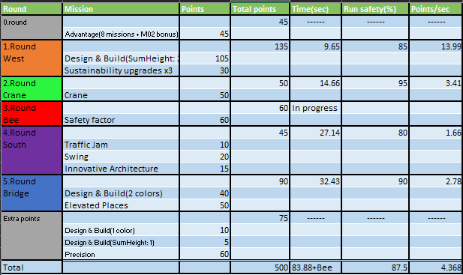

**Attachments and Front-achments for Base robot**

|  |  |
| --- | --- |
|  | Attachment |
| 1.Round West | Tractor |
| 2.Round Crane | Farmer |
| 3.Round South | Lifter |
| 4.Round Bridge | Candy |

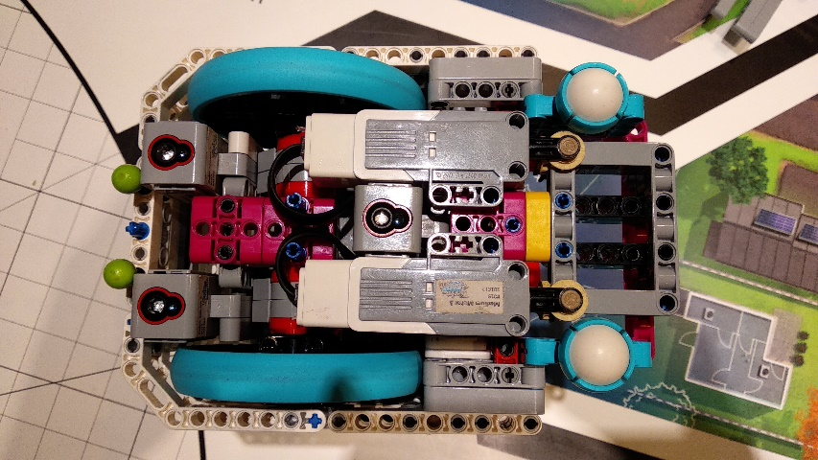**Durability**

Our goal: robust construction, no repairs

Robust, Stable Structure

DRIVEN WHEELS: - the wheels are fixed by a long axle, a wheel is fixed with 2-2 biscuits to stabilize the wheels, that don't touch the motor and the side  
- The wheels are attached by the axle to the frame, therefore, it cannot be strained downward or upward.  
- The wheels are good because they’re way less pressable than any other wheels out, they’re big enough to carry our robot fast but they’re not too big, that they fit into our robot very well.   
UTILITY BALLS: - Our following balls are from the new Spike Prime set  
-They’re easy to fix to the robot  
-They’re better than the metal ones because they have less weight and they’re could be precise due to the center of mass

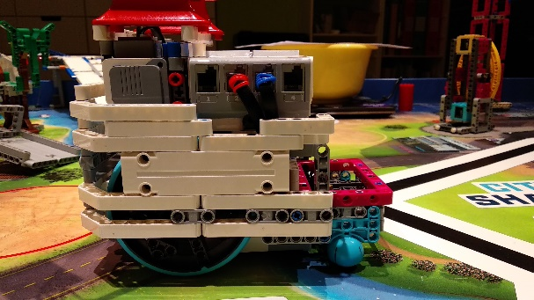LARGE MOTORs: - It is attached to the side of our brick, this is a very secure type of fixing it to the robot because there are a lot of holes in the side of the brick  
- The large motors horizontal, because the big wheels are at the back, they look downwards, because they have more weight on them and this helps keeping them in places, and they use less space  
- It looks back because with the rear wheel drive we can made a stronger, faster robot  
FRAME: - the frame is rectangular, but the front aren’t in the frame, because we could made it smaller this way and our goal was to make a small but robust robot.  
- it keeps the brick and the wheels in its place  
-18 units high, 24 units long and 18 units wide  
.BRICK: -the brick is on the back of the robot, its bottom is tightly secured to the inner robot.  
- Our cables are well ordered and nicely driven through the robot.  
- There is also a separate channel to avoid contact with the wheel.

ITM AND THE MEDIUM MOTORS: - the middle motors are on the bottom of the robot, and we take the rotation with a simple gear transmission.  
- The ITM fixed to the medium motors with axles, which makes it easy for the engine to rotate the attachment.  
- The medium motors are attached to the suspension, the wheel and the frame.  
- The is pretty innovative thanks to the Spike big frame and biscuits, which helped us to create a secure and innovative, easy-to-use transmitting mechanism  
ITM = Innovative Transmitting Mechanism

GYRO: - the gyro sensor is attached to the inner frame of the robots very strongly.  
CABLE DRAINING: - the cables are clamped down so that they do not get caught in anything.  
We've also made the robot's Lego Digital Designer version so we can attempt freely without risk

**Mechanical Efficiency**

Our goal: ideal for tasks, can be used universally

Our robot is modular so it's easy to disassemble.  
This is very useful if we need to modify or have to replace a motor or sensor in the robot or have an idea for improvement. There are 6 main modules in our robot: frame, large motors, medium motors, brick, sensors, and the robot's center.

**Frame:** Includes all elements that hold unite and cover the robot.

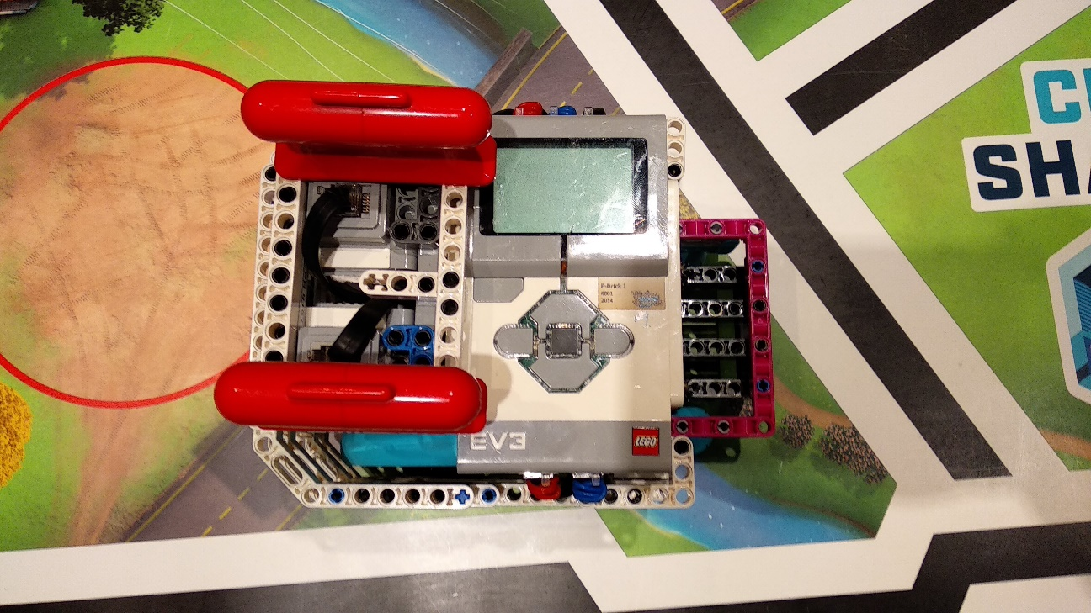**Large motors:** It includes the two large motors and a special frame on them which can fix the motors into the back of the robot. This part also includes the biscuits which attach the wheels.  
**Medium motors:** The two medium motors, the middle part frame and the out-of-frame outlets are included in this module.  
**Brick:** This module contains an Ev3 LEGO brick.  
**Sensors:** It includes 3 color and one gyro sensor which is in the center of the robot so it is in both modules  
**Centre:** This module contains beam frames and a few complementary elements. This module holds everything in one piece.

**Precision**

Our goal: solved all the tasks with high precision and reliability

We always choose the right speed for the different models. It is going slower in curvy parts to make it more accurate. At the end of the fast sections, the robot slows down for accuracy. **Before the models the robot always slows down to be more accurate**.

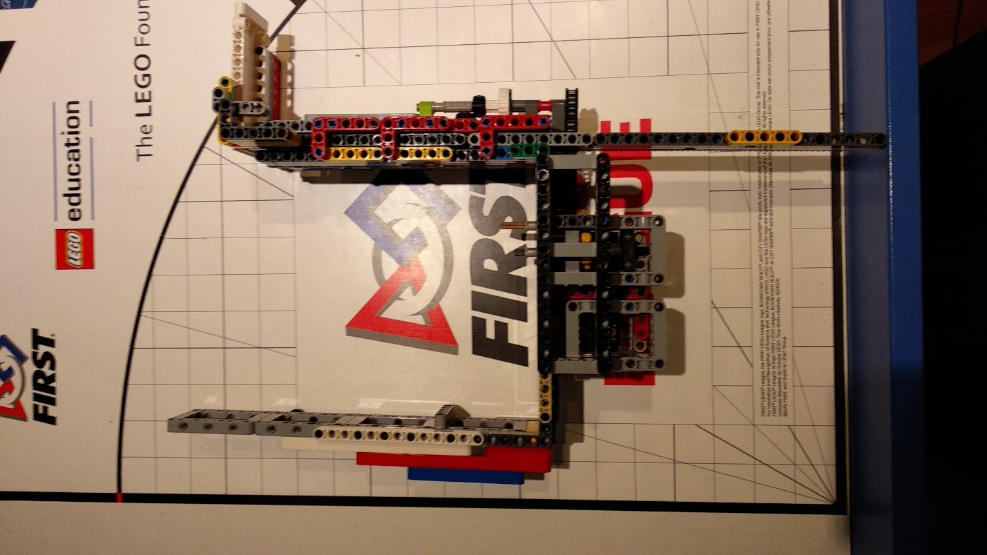 We prefer to use deflectors that help in precision. We also turn the wall to our advantage, so the robot can easily adjust without lines.

We are also adjusted to properly stable models. The robot does not make any sudden movements to avoid slipping and make a mistake. Slipping is also hindered by gradual acceleration and deceleration at turning and at going straight.

**Strength, Sustainability**

Our goal: Robot goes easy on structures, objects or itself

* **Software:**

In our program, we are gradually changing the speed to protect models. We are approaching everything slowly, carefully and guardedly.

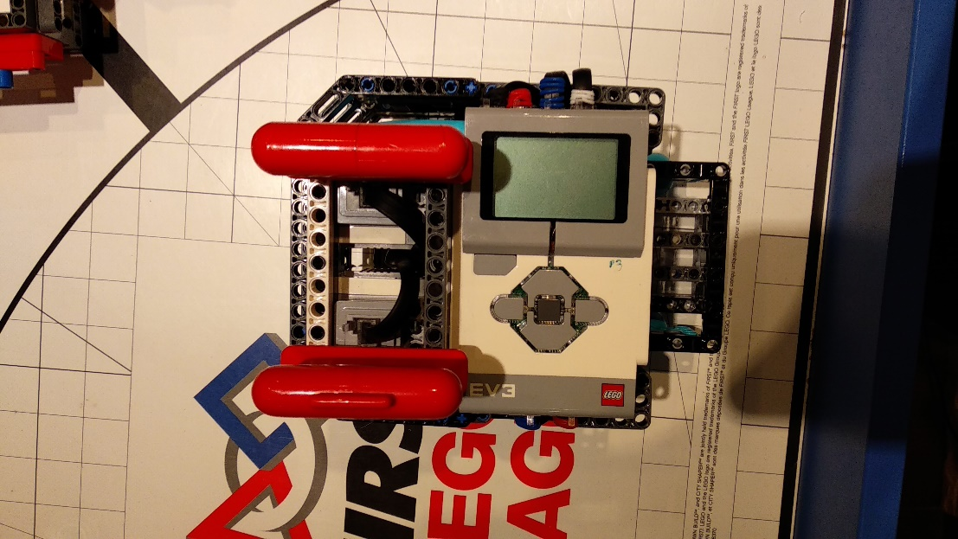

* **Hardware:**

Our robot is able to exert large strength, because of the proper transmission, but we do not use it for wrecking.   
We like to use clamping mechanism to reduce the chance of destruction e.g. at the safety factor.

**Mission Strategy – SF**

**Mission Strategy**

Our goal: very clear, purposefully to maximize points

Our goal: very clear, purposefully to maximize points

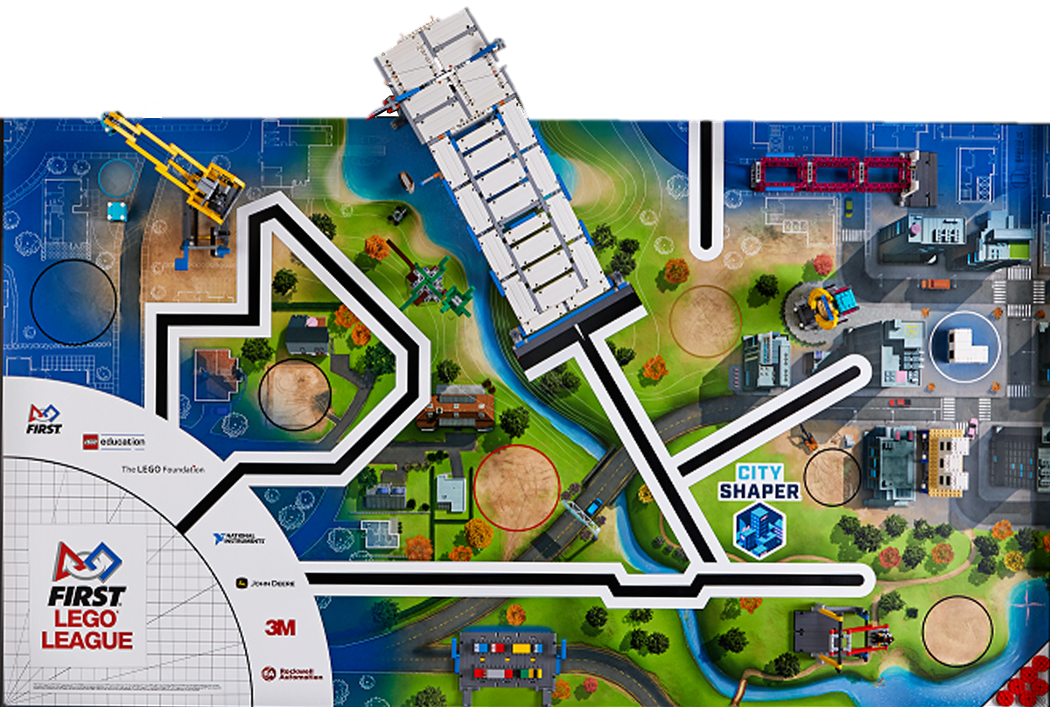

1.round: Design & Build(sumheight:21), Sustainability upgrades x3, Base

2. round: Crane, Design For Wildlife, Inspection Drone, Base

3. round: Traffic Jam, Swing, Safety Factor, Elevator, Innovative Architecture, Base

4. round: Design and Build(2 colors), Elevated Places

**Mission Strategy – Regional**

**Mission Strategy**



1.round: Design & Build(sumheight:21), Sustainability upgrades x3, Base

2. round: Crane, Base

3. round: Safety factor, Base

4. round: Traffic Jam, Swing, Innovative Architecture, Base

5. round: Design and Build (2 colors), Elevated Places

**2014 World Class**

**2016 Animal Allies**

**Design Process**

**Robot Evolution by years**

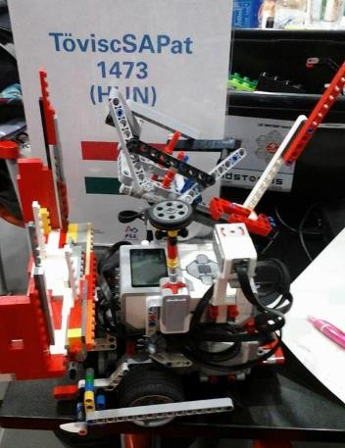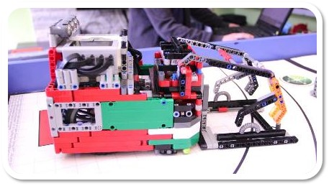

**2015 Trash Trek**

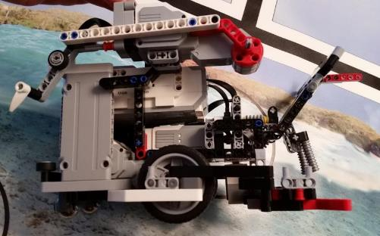

**2018 Into Orbit**

**2017 Hydro Dynamics**

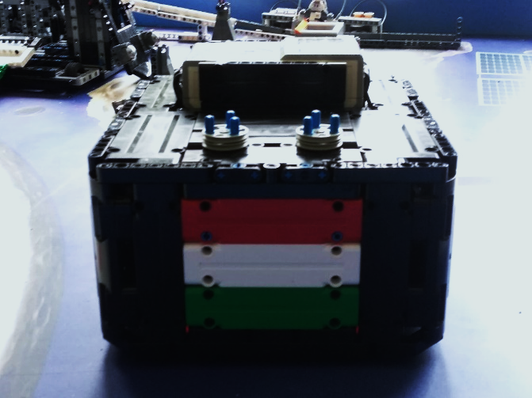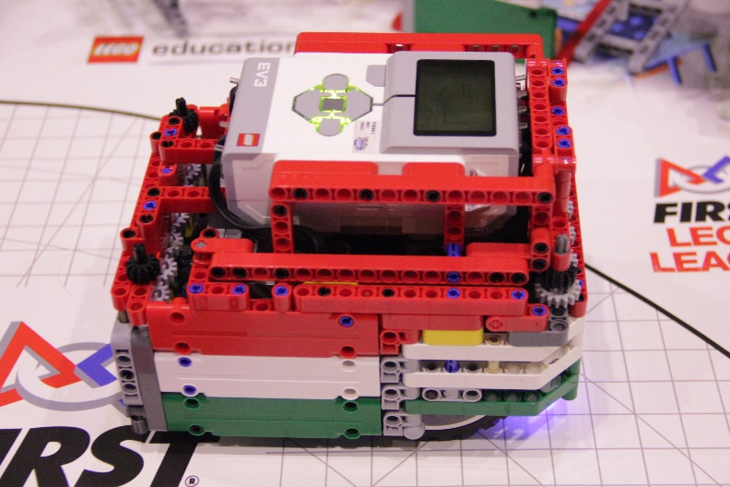

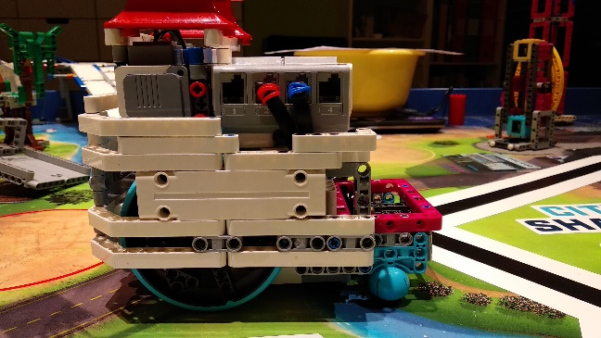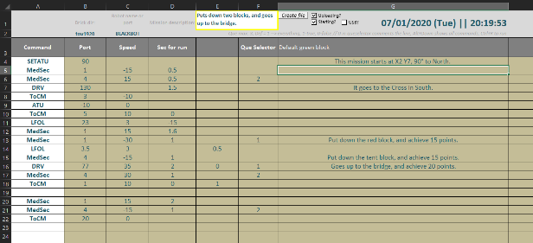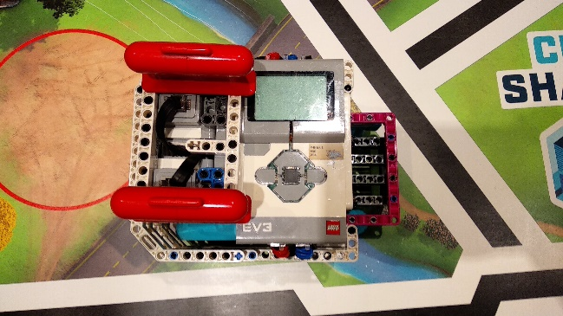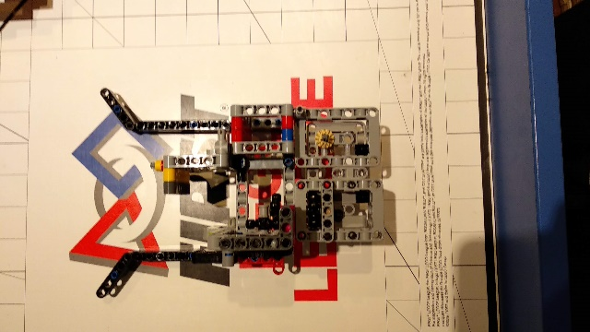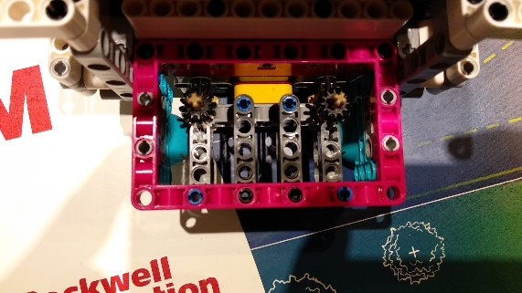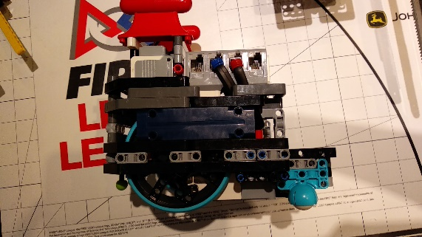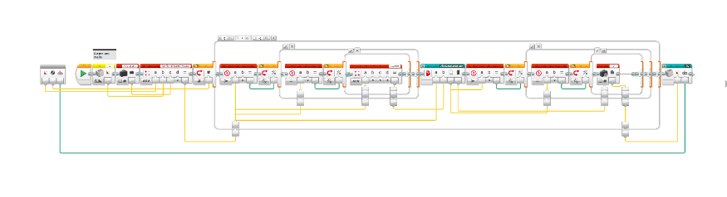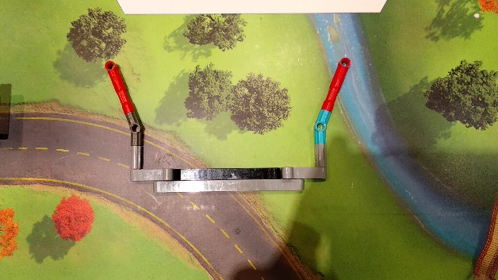

Our goal: robot designed by the team itself, unique, creative

Our goal: robot designed by the team itself, unique, creative

**Innovation Elements**

**Innovation Elements**

This year, we use a frontachment that isn’t attached to the robot but it’s on the front of it and this can help the robot to easily adjust to the bee model and then we can leave it there

We use solutions without motor drive. They do their task "passively". We use these to Crane, Design and Build, Innovative Architecture, Swing, Sustainability upgrades.

This year we placed our big motors vertically, because we could build a way smaller robot with it and small robot is good for this mat because the Advantage “mission” and because there a lot of places on the mat where only a small robot can fit in.

Our big innovation are the Spike elements in our robot especially the big wheels because they’re exactly the right size for our robot they’re strong so not really pushable, what is good when working with greater weights.

This year, we use a frontachment that isn’t attached to the robot but it’s on the front of it and this can help the robot to easily adjust to the bee model and then we can leave it there

We use solutions without motor drive. They do their task "passively". We use these to Crane, Design and Build, Innovative Architecture, Swing, Sustainability upgrades.

This year we placed our big motors vertically, because we could build a way smaller robot with it and small robot is good for this mat because the Advantage “mission” and because there a lot of places on the mat where only a small robot can fit in.

Our big innovation are the Spike elements in our robot especially the big wheels because they’re exactly the right size for our robot they’re strong so not really pushable, what is good when working with greater weights.

Our big innovation this year is the ATU myblock, which is good for turning to an absolute value in degrees and that’s good because we always know where to robot heads from the absolute north so this makes programming easier

Our other really big innovation is our Interpreter program what translates an excel file to a text file and automaticly uploads it to the robot and starts a program on the robot, that can understand the commands in the text file and can perform them.

In our attachments we use LEGO boat weights as counterweights, because they are heavy enough but they don't need too much space.

Our medium motor pass the rotation with an innovative solution using the new beam frame from Spike set. So with this we can build an attachment base lot faster than in previous years

Our big innovation this year is the ATU myblock, which is good for turning to an absolute value in degrees and that’s good because we always know where to robot heads from the absolute north so this makes programming easier

Our other really big innovation is our Interpreter program what translates an excel file to a text file and automaticly uploads it to the robot and starts a program on the robot, that can understand the commands in the text file and can perform them.

In our attachments we use LEGO boat weights as counterweights, because they are heavy enough but they don't need too much space.

Our medium motor pass the rotation with an innovative solution using the new beam frame from Spike set. So with this we can build an attachment base lot faster than in previous years

**Robot Design/ Appearance**

Our goal: efficient, beneficial, elegant

Our robot is designed to be inspiring to anyone who looks at it and to solve as many missions as possible and as consistent as possible. It is colorful thanks to the Spike Prime elements. It has a frame to keep the sides together, but it doesn’t cover the front of our robot because we could have the ITM lower this way. This is good, because a lot of models must be solved very low. E.g.: Safety factor and the swing. We tried a lot of things to make this robot, we created countless tests and finally came up with this.

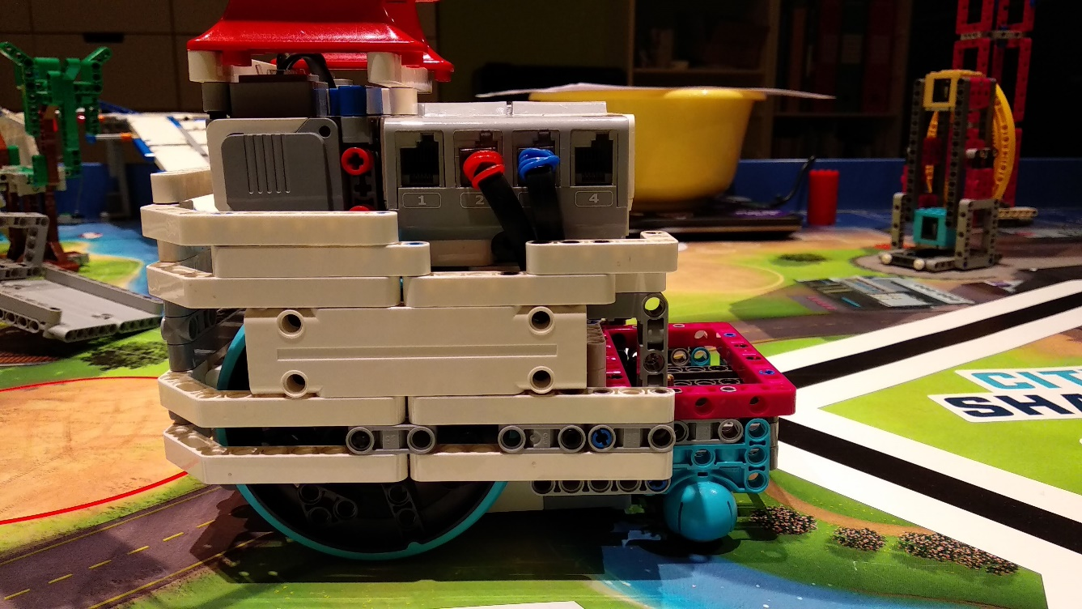

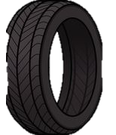

Mechanical Parts Testing

**Test: DRV BLOCK testing**



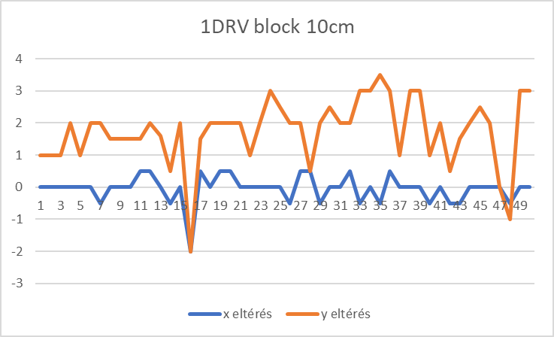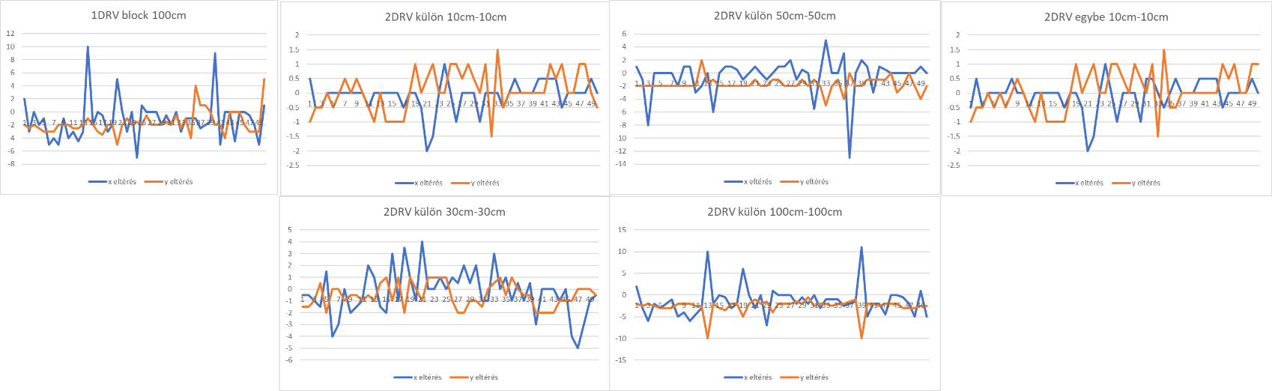

**Test: MOTOR TESTS**

At the end of the summer we tested 12 pieces of EV3 Motors from the viewpoint of reilability, performance, matching and accuracy and we selected for the race robot the two most stabile motors.

END RESULT: We have selected the two most fitting and similar, high performing motors

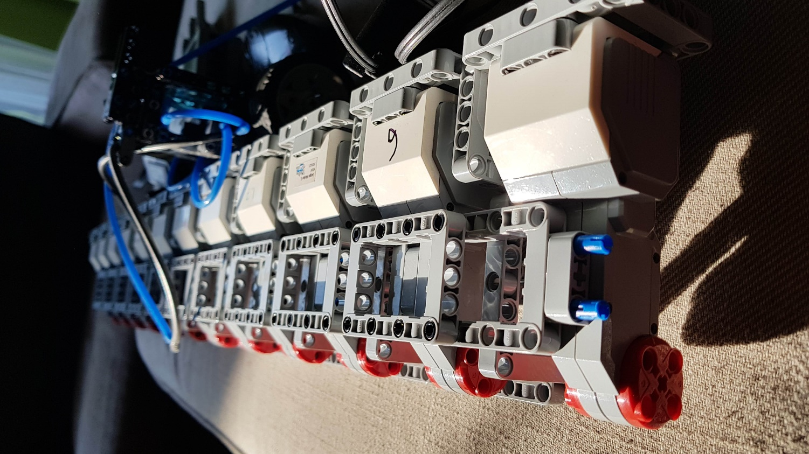

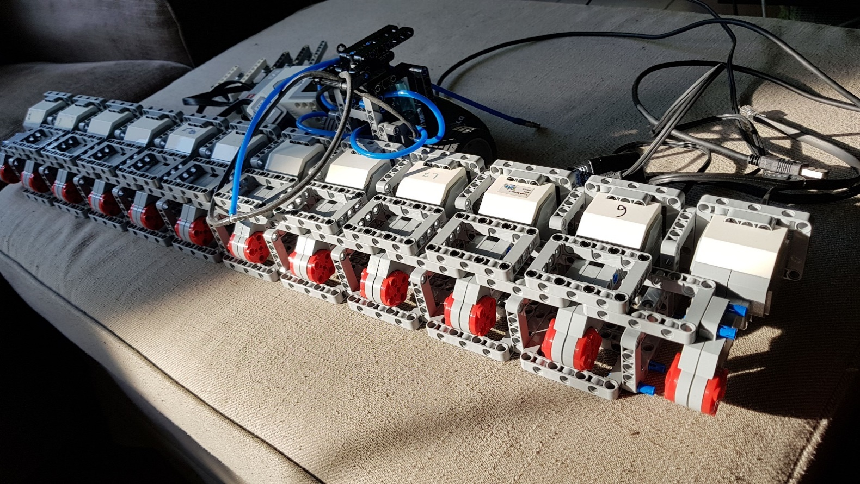

|  |  |  |
| --- | --- | --- |
|  |  |  |

Spike Prime parts

**Where did we get it?**

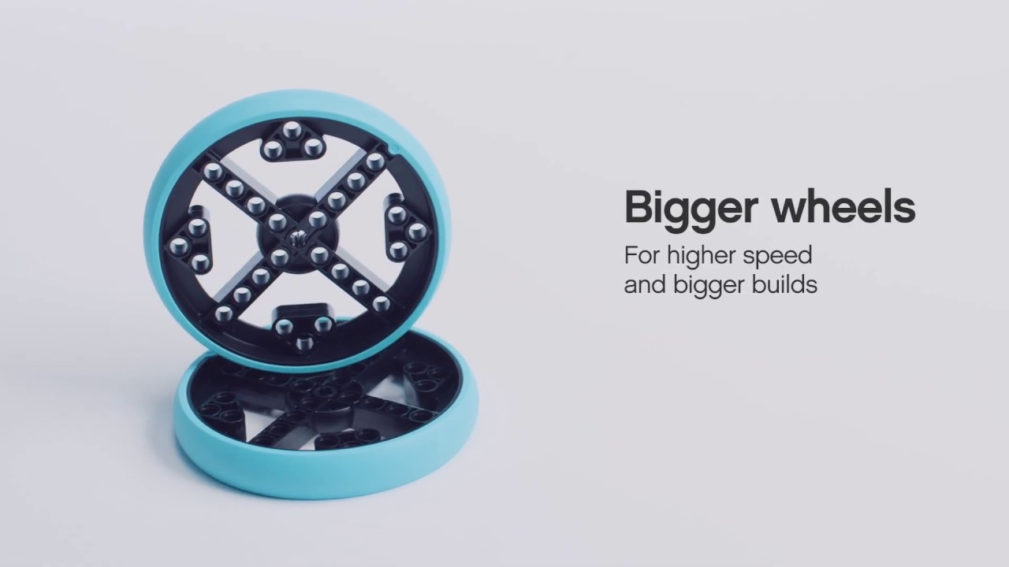I’m sure you already noticed, that we have a lot of Spike Prime Lego parts in our robot. And finally, here comes the explanation. We have seen all these parts at the Detroit World Final last year all these elements are so cool so that’s why we started to look after these. At the start of the season we found the part numbers of all the Spike Prime elements and also some parts were on Bricklink so we don’t wasted our time and bought some. The first were the biscuits than the larger beam frames. Finally we tried to order some of the coolest wheel what we have ever seen (and using now). We ordered it from the official Lego website – Bricks & pieces. We have seen this wheel as mentoined earlier at the world final and we planned our whole robot idea around this wheel by just using a similar size also very popular 81.6mm wheel.

**Why we use them?**

We use a lot of them efficiently but i would like to highlight some of them which i think helped us the most.

**Biscuits**

They’re very useful because they have a lot of pinholes to use just at the right points when you need them, we used them a lot escpecially in our robot e.g.: ITM, fasten the wheels

**Big yellow pinhole plate**

They’re useful at testing, because you can build models to it and take away them from the mat or you can try something new without the robot thanks to the robot simulator built to them, or you can experiment with gears easily, without much to build other than gears

**Medium beam frame**

This is the base of the ITM

**Big wheel**

This the best wheel I’ve seen so far because it is almost unpressable it’s big but fits into a lot of designs i’ve seen.

We love all the Spike Prime elements because they’re pretty useful and colorful